**Name :: himanshu kumar**

**USN :: 1nt21is063**

**Sec :: A**

**AIM –** Simple Queue Using Linked List

**ALGORITHM –**

**STEP 1 –** Allocate the spaces for the new node PTR

**STEP 2 –** Set PTR -> DATA = VAL

**STEP 3 –** IF FRONT = NULL

SET FRONT = REAR = NULL

SET FRONT -> NEXT = REAR -> NEXT = NULL

ELSE

SET REAR -> NEXT = NULL

SET REAR = PTR

SET REAR -> NEXT = NULL

(END OF IF)

**STEP 4 -** END

**CODE –**

#include<stdio.h>

#include<stdlib.h>

struct node

{

int data;

struct node *next;

};

struct node *front;

struct node *rear;

void insert();

void delete();

void display();

void main ()

{

int choice;

while(choice != 4)

{

printf("\n*************************Main Menu*****************************\n");

printf("\n=================================================================\n");

printf("\n1.insert an element\n2.Delete an element\n3.Display the queue\n4.Exit\n");

printf("\nEnter your choice ?");

scanf("%d",& choice);

switch(choice)

{

case 1:

insert();

break;

case 2:

delete();

break;

case 3:

display();

break;

case 4:

exit(0);

break;

default:

printf("\nEnter valid choice??\n");

}

}

}

void insert()

{

struct node *ptr;

int item;

ptr = (struct node *) malloc (sizeof(struct node));

if(ptr == NULL)

{

printf("\nOVERFLOW\n");

return;

}

else

{

printf("\nEnter value?\n");

scanf("%d",&item);

ptr -> data = item;

if(front == NULL)

{

front = ptr;

rear = ptr;

front -> next = NULL;

rear -> next = NULL;

}

else

{

rear -> next = ptr;

rear = ptr;

rear->next = NULL;

}

}

}

void delete ()

{

struct node *ptr;

if(front == NULL)

{

printf("\nUNDERFLOW\n");

return;

}

else

{

ptr = front;

front = front -> next;

free(ptr);

}

}

void display()

{

struct node *ptr;

ptr = front;

if(front == NULL)

{

printf("\nEmpty queue\n");

}

else

{ printf("\nprinting values .....\n");

while(ptr != NULL)

{

printf("\n%d\n",ptr -> data);

ptr = ptr -> next;

}

}

}

**OUTPUT –**

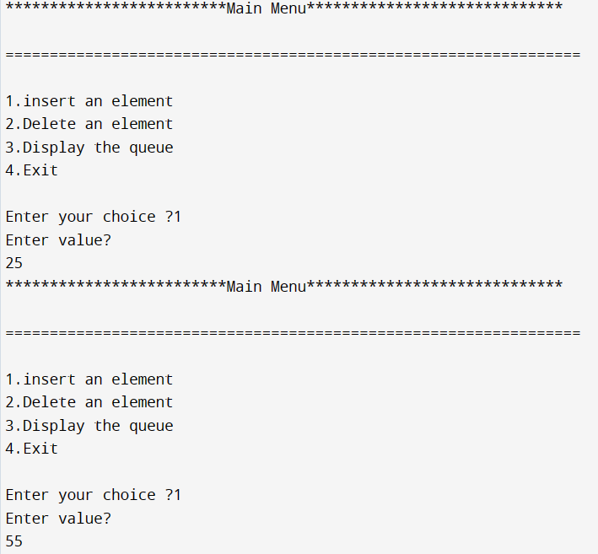

**Link:**[**https://github.com/himanshu120299/Lab-assignment.git**](https://github.com/himanshu120299/Lab-assignment.git)